*LED Flasher using 3 LED*

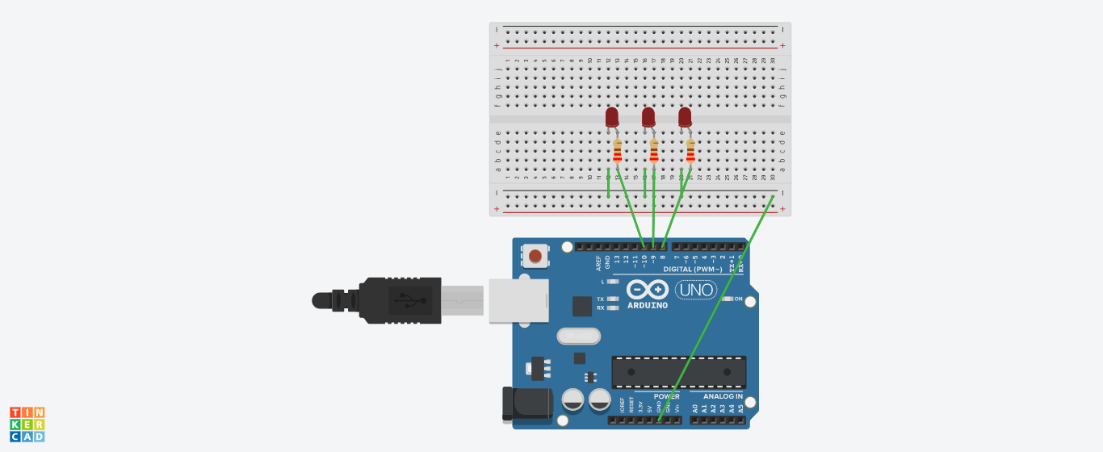

*CODE:*

void setup()

{

pinMode(8,OUTPUT);

pinMode(9, OUTPUT);

pinMode(10,OUTPUT);

}

void loop()

{

digitalWrite(8,HIGH);

digitalWrite(9,HIGH);

digitalWrite(10,HIGH);

delay(800);

digitalWrite(8,LOW);

digitalWrite(9,LOW);

digitalWrite(10,LOW);

delay(800);

}